**KPI in SQL Queries**

**Total revenue:**

SELECT SUM(total_price) AS total_revenue FROM pizza_sales;

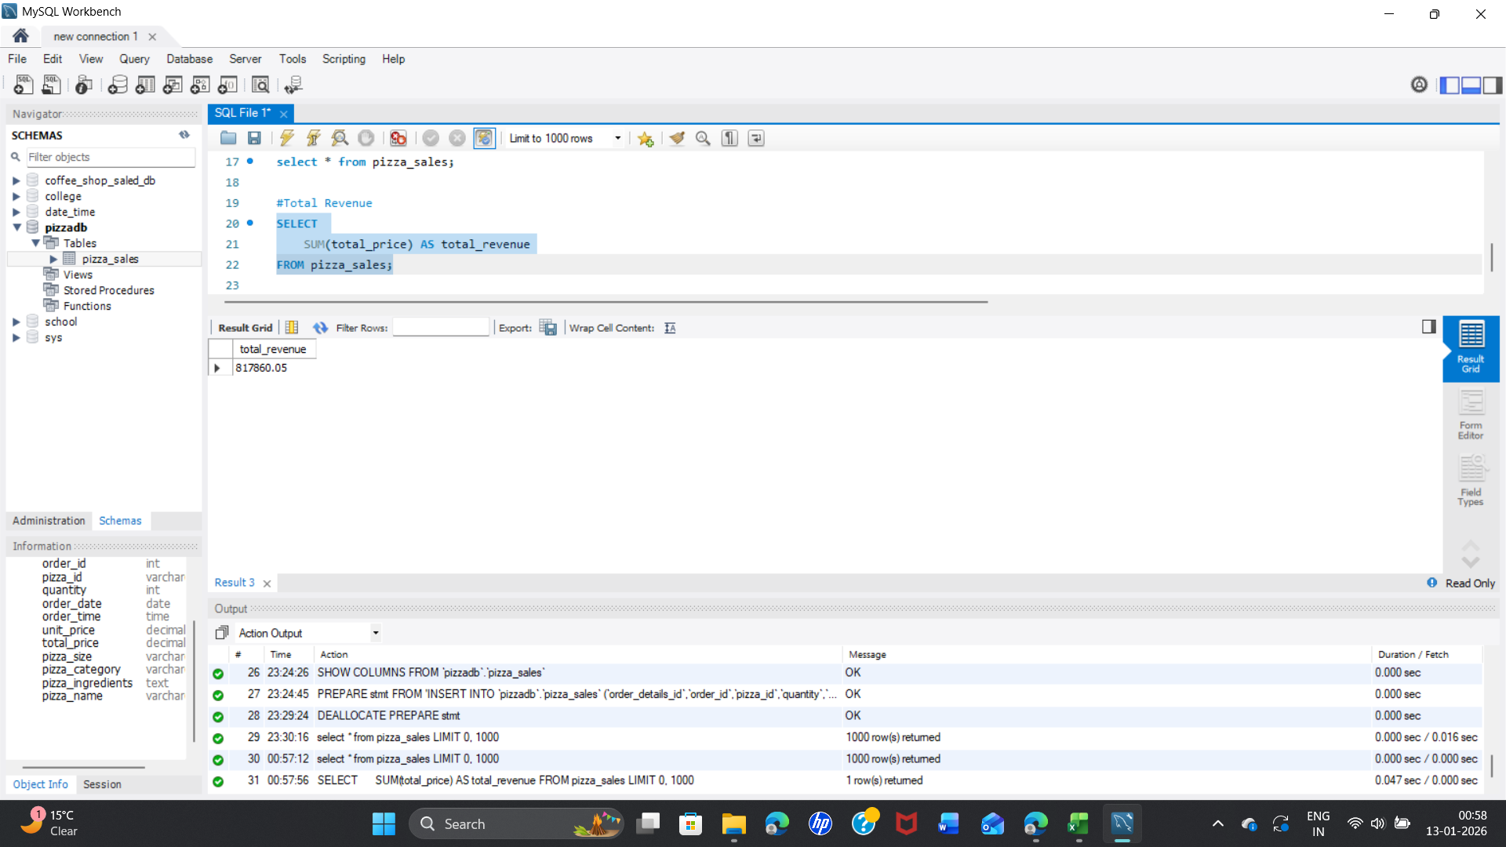

**Total Orders:**

SELECT COUNT(DISTINCT order_id) AS total_orders FROM pizza_sales;

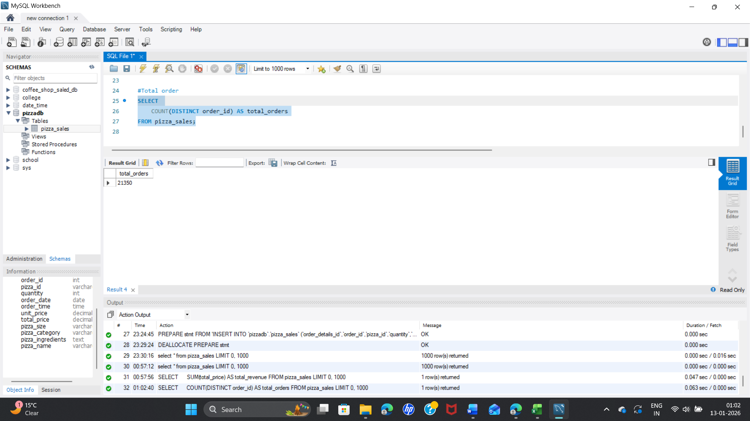

**Total Pizzas Sold:**

SELECT SUM(quantity) AS total_pizzas_sold FROM pizza_sales; 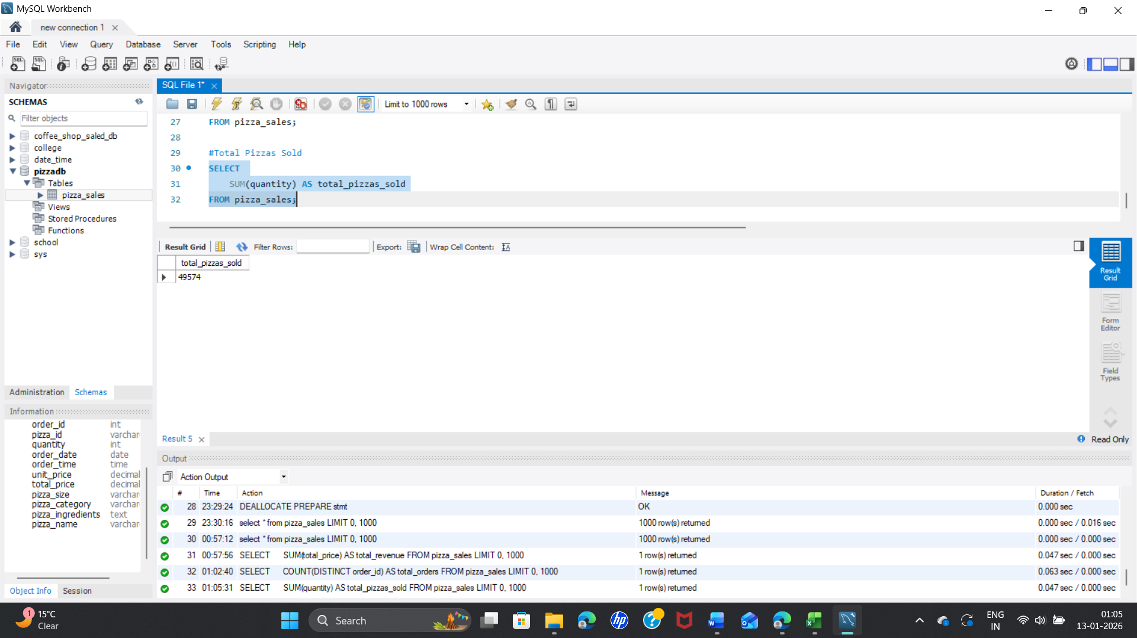

**Average Order Value**

SELECT ROUND(SUM(total_price) / COUNT(DISTINCT order_id), 2) AS avg_order_value FROM pizza_sales;

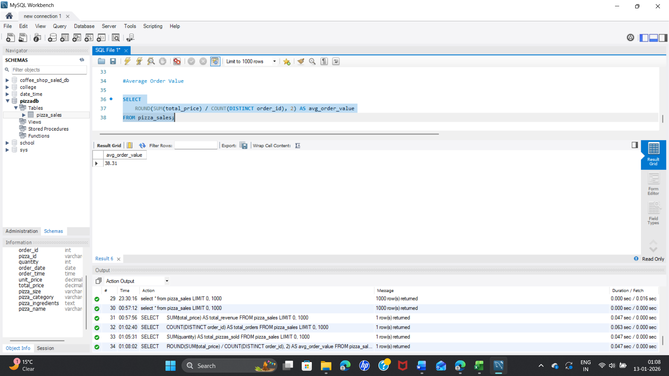

**Average Pizzas per Order:** total pizza sold/ total order

SELECT

ROUND(SUM(quantity) * 1.0 / COUNT(DISTINCT order_id), 2) AS avg_pizzas_per_order

FROM pizza_sales;

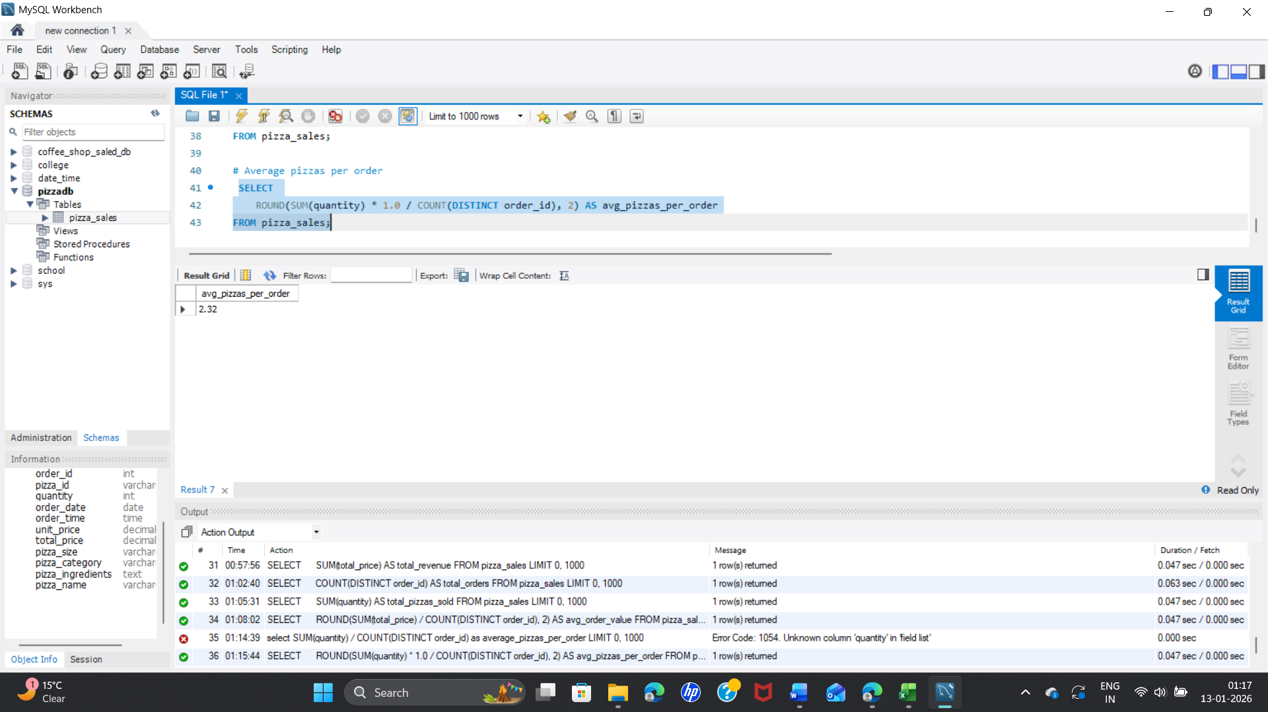

**Orders by Hour**

SELECT

HOUR(order_time) AS order_hour,

COUNT(DISTINCT order_id) AS total_orders

FROM pizza_sales

GROUP BY order_hour

ORDER BY total_orders DESC;

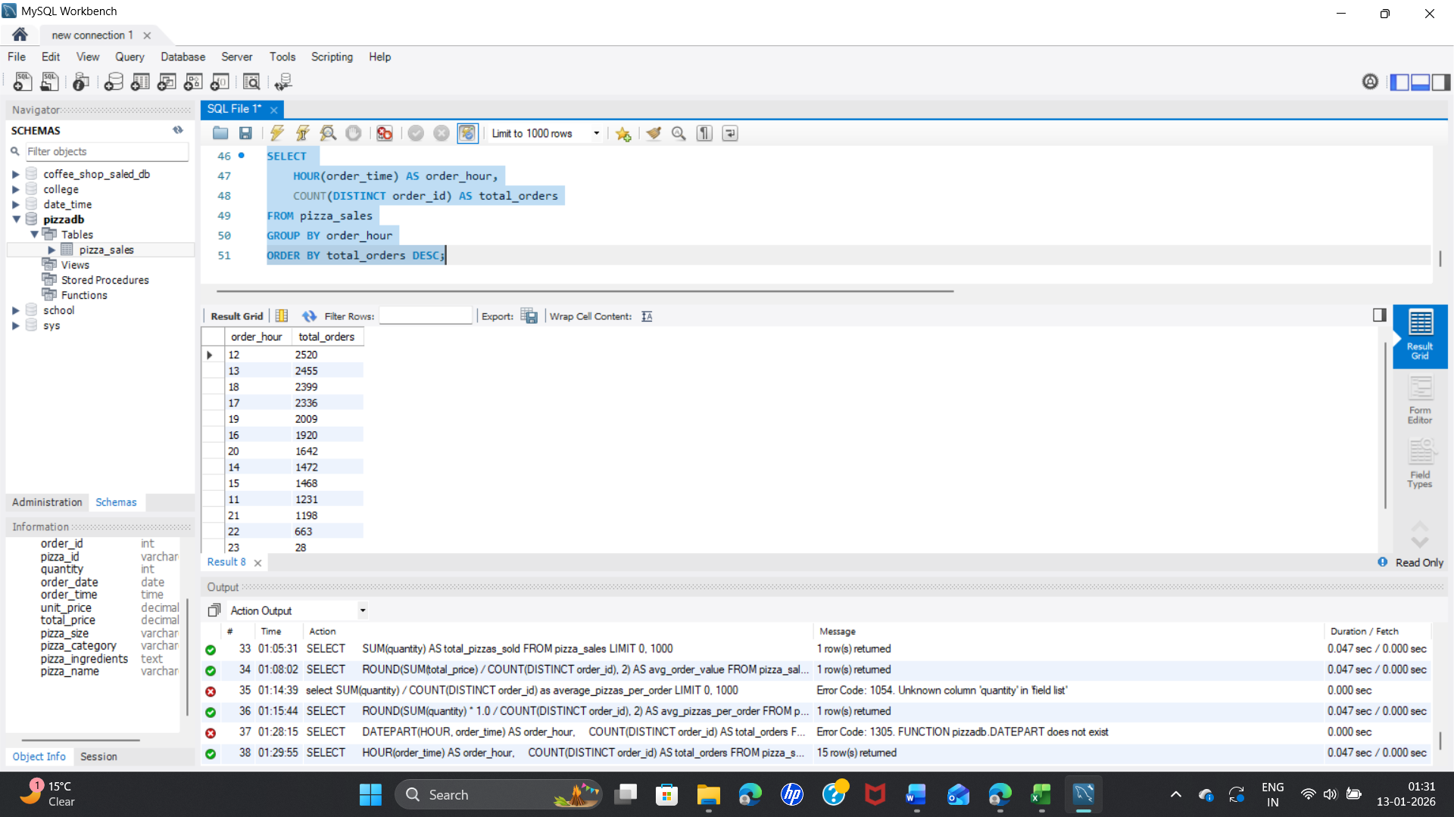

**Revenue by Hour**

SELECT

HOUR(order_time) AS order_hour,

SUM(total_price) AS total_revenue

FROM pizza_sales

GROUP BY order_hour

ORDER BY total_revenue DESC; 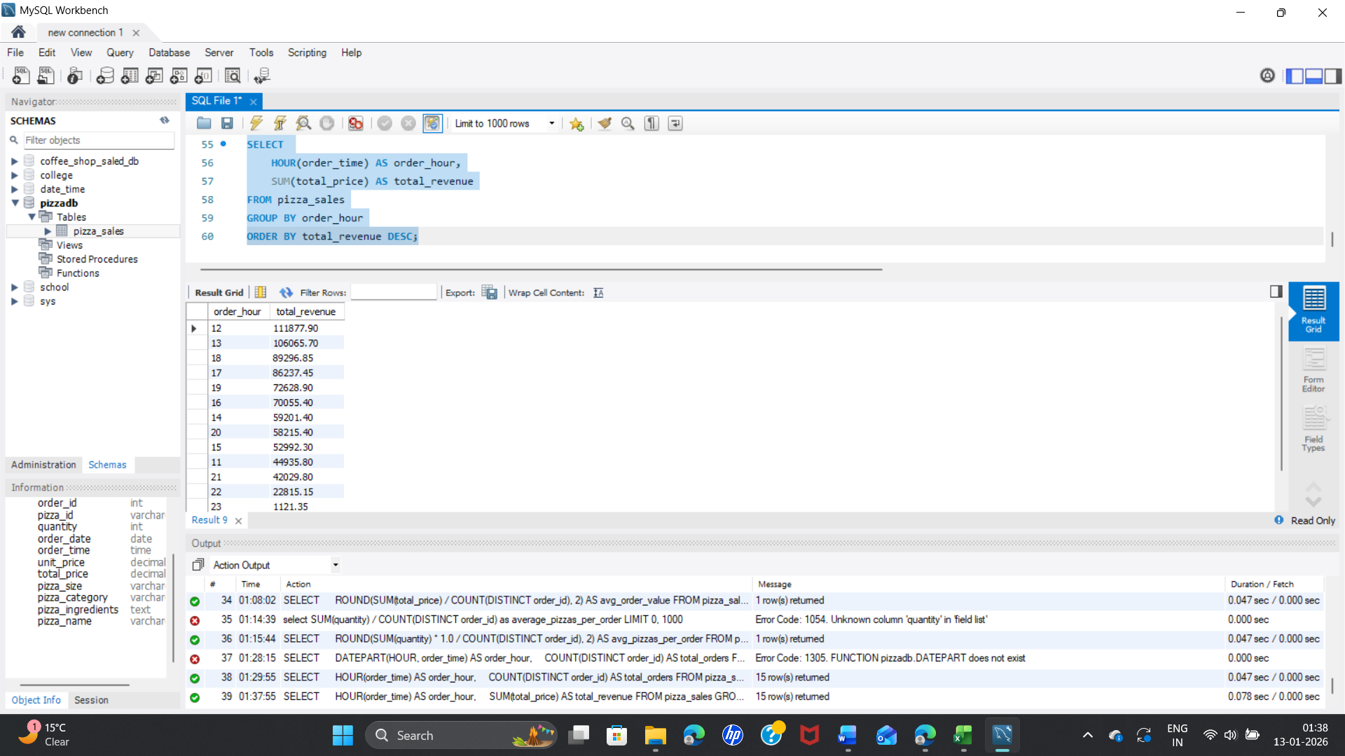

**Orders by Day of Week:**

SELECT

DAYNAME(order_date) AS day_name,

COUNT(DISTINCT order_id) AS total_orders

FROM pizza_sales

GROUP BY day_name

ORDER BY total_orders DESC;

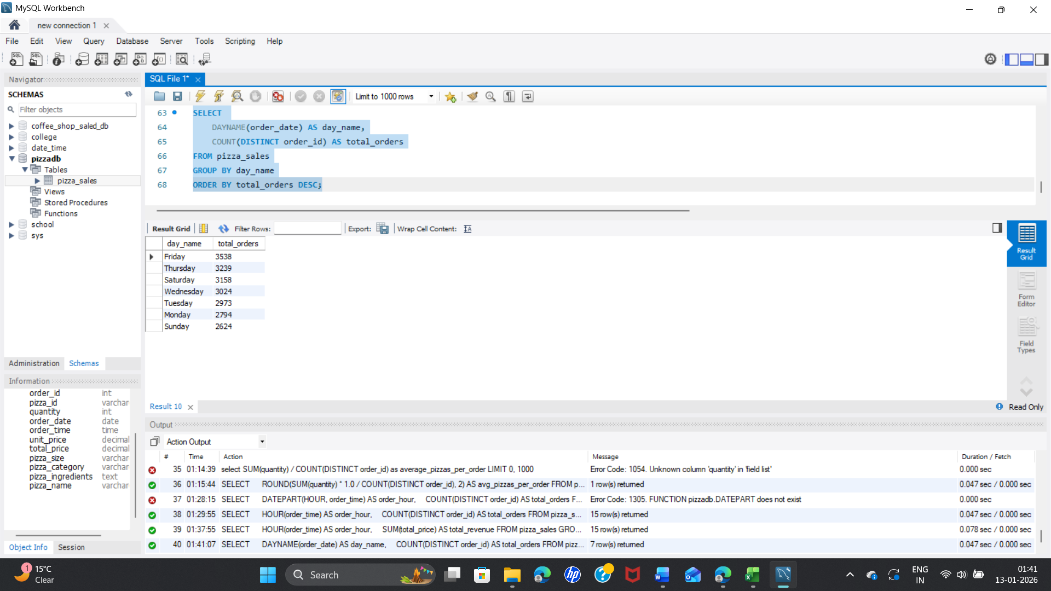

**Monthly Revenue Trend**

SELECT

MONTH(order_date) AS month_no,

MONTHNAME(order_date) AS month_name,

ROUND(SUM(total_price), 2) AS monthly_revenue

FROM pizza_sales

GROUP BY month_no, month_name

ORDER BY month_no;

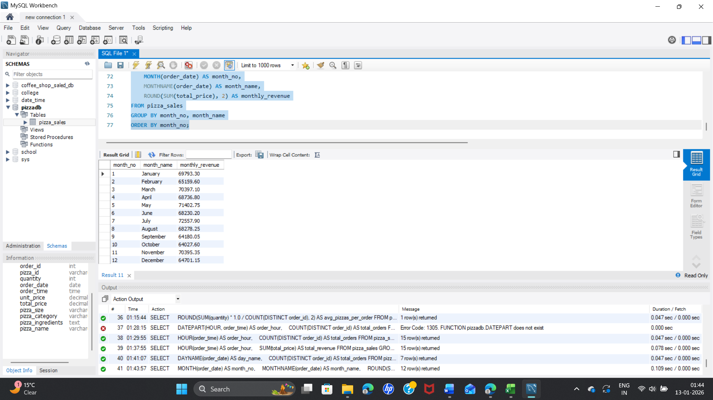

**Best-Selling Pizzas (Top 5)**

SELECT

pizza_name,

SUM(quantity) AS total_sold

FROM pizza_sales

GROUP BY pizza_name

ORDER BY total_sold DESC

LIMIT 5;

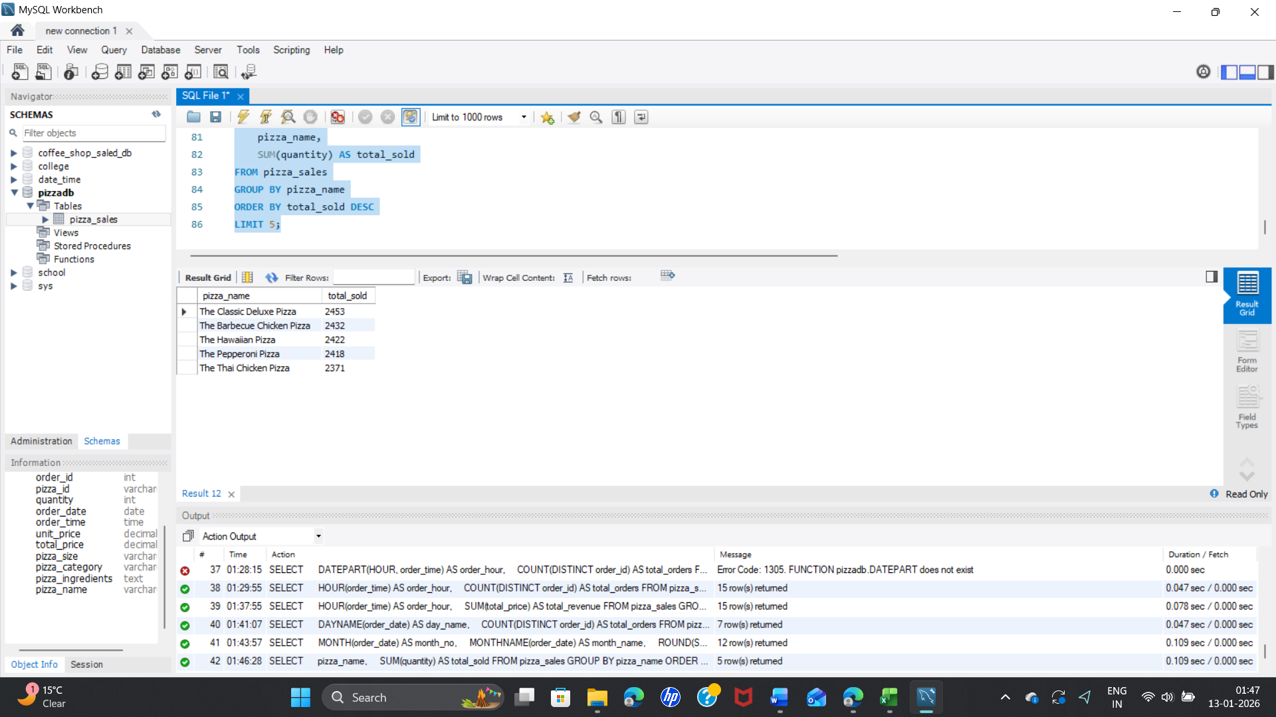

**Worst-Selling Pizzas (Bottom 5)**

SELECT

pizza_name,

SUM(quantity) AS total_sold

FROM pizza_sales

GROUP BY pizza_name

ORDER BY total_sold ASC

LIMIT 5;

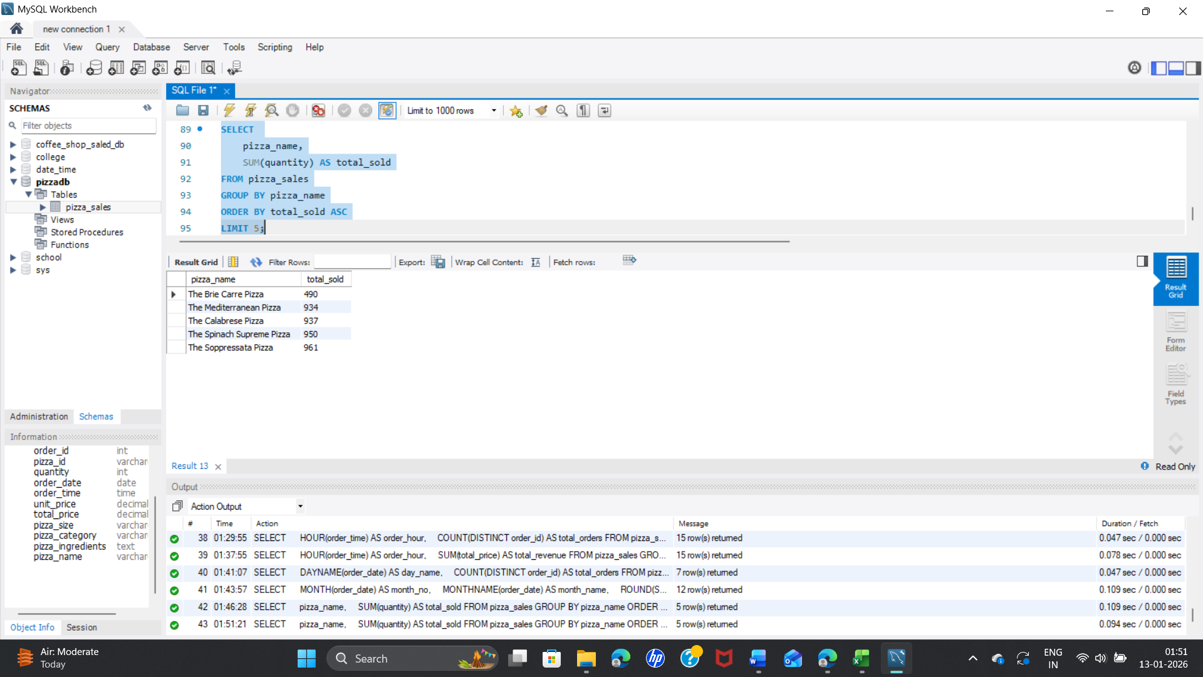

**Top Revenue Pizzas**

SELECT

pizza_name,

ROUND(SUM(total_price), 2) AS revenue

FROM pizza_sales

GROUP BY pizza_name

ORDER BY revenue DESC

LIMIT 5;

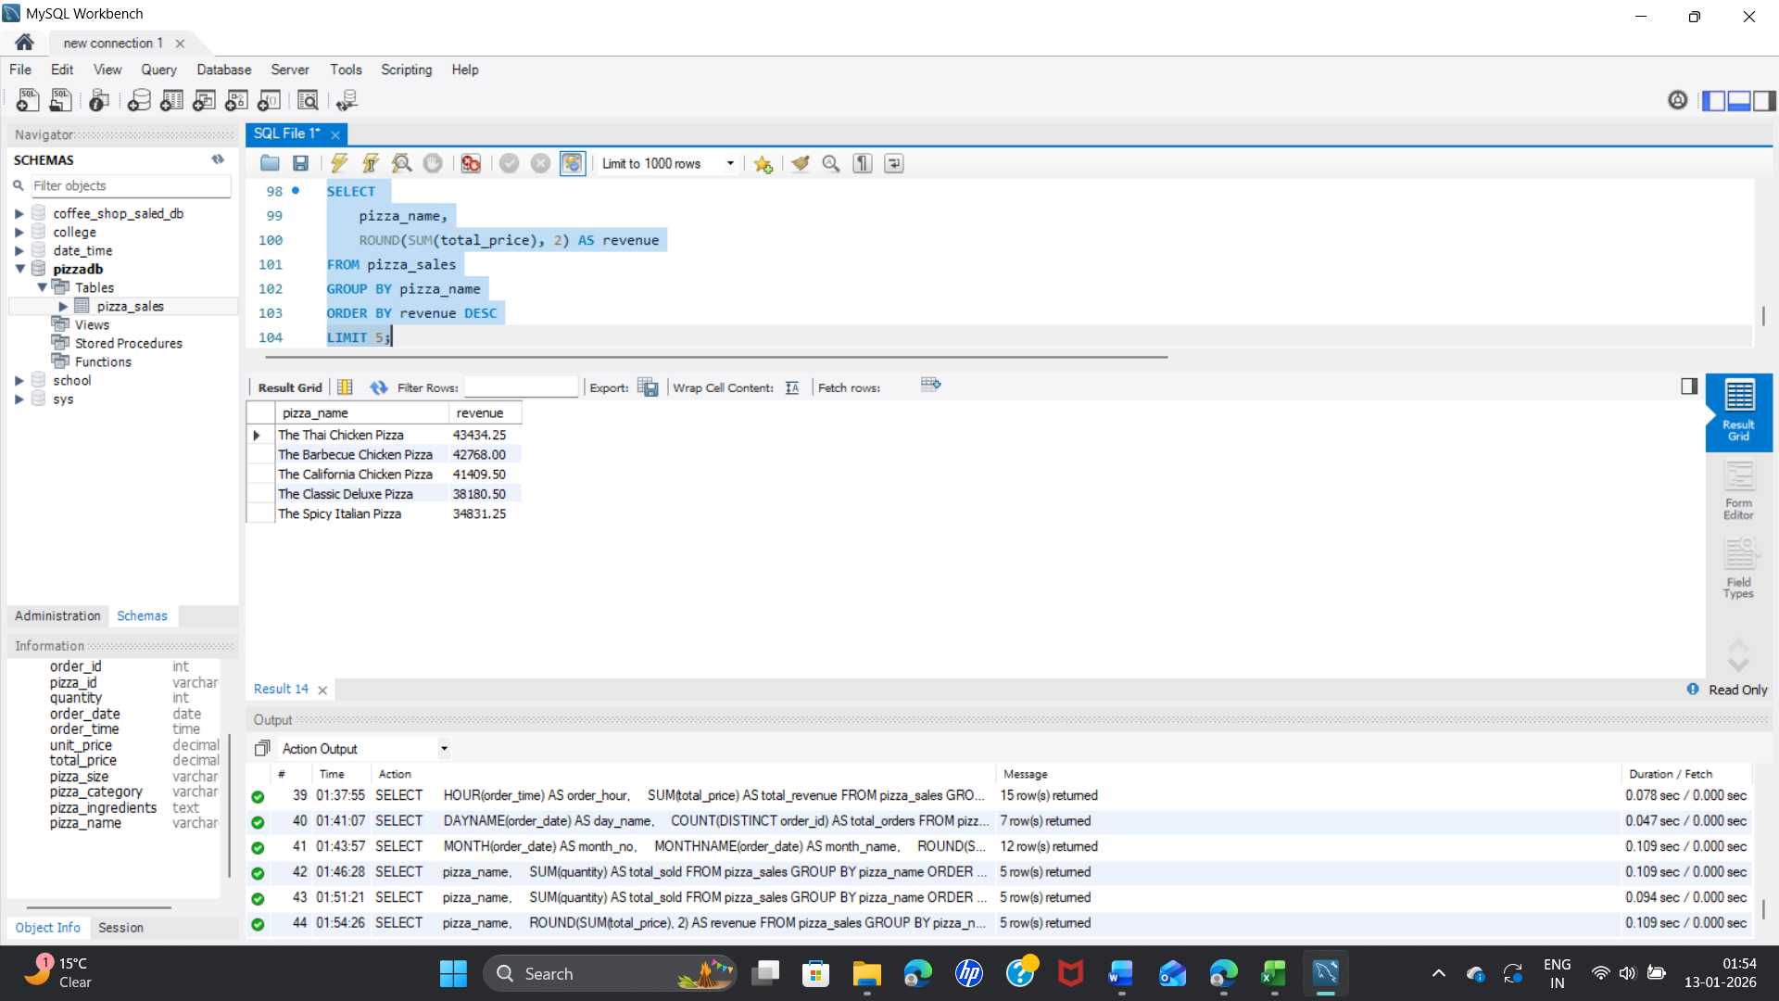

**Revenue % by Pizza Size**

It shows what percentage of total revenue comes from each pizza size  
(Small, Medium, Large, XL, etc.).

SELECT

pizza_size,

ROUND(SUM(total_price) * 100 / (SELECT SUM(total_price) FROM pizza_sales), 2)

AS revenue_pct

FROM pizza_sales

GROUP BY pizza_size

ORDER BY revenue_pct DESC;

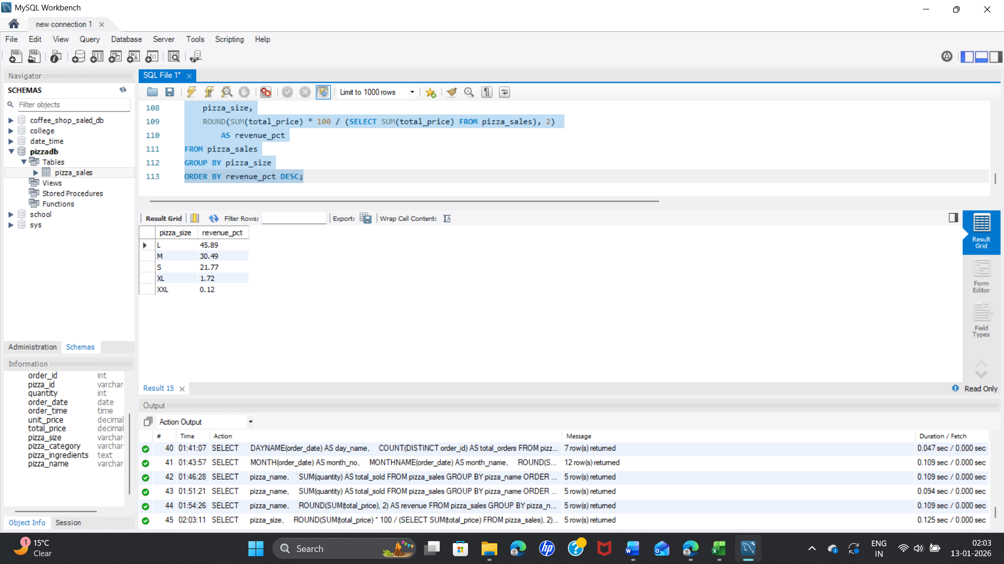

**Pizzas Sold by Category (Classic, Chicken, Veggie, Supreme)**

SELECT

pizza_category,

SUM(quantity) AS total_pizzas

FROM pizza_sales

GROUP BY pizza_category

ORDER BY total_pizzas DESC;

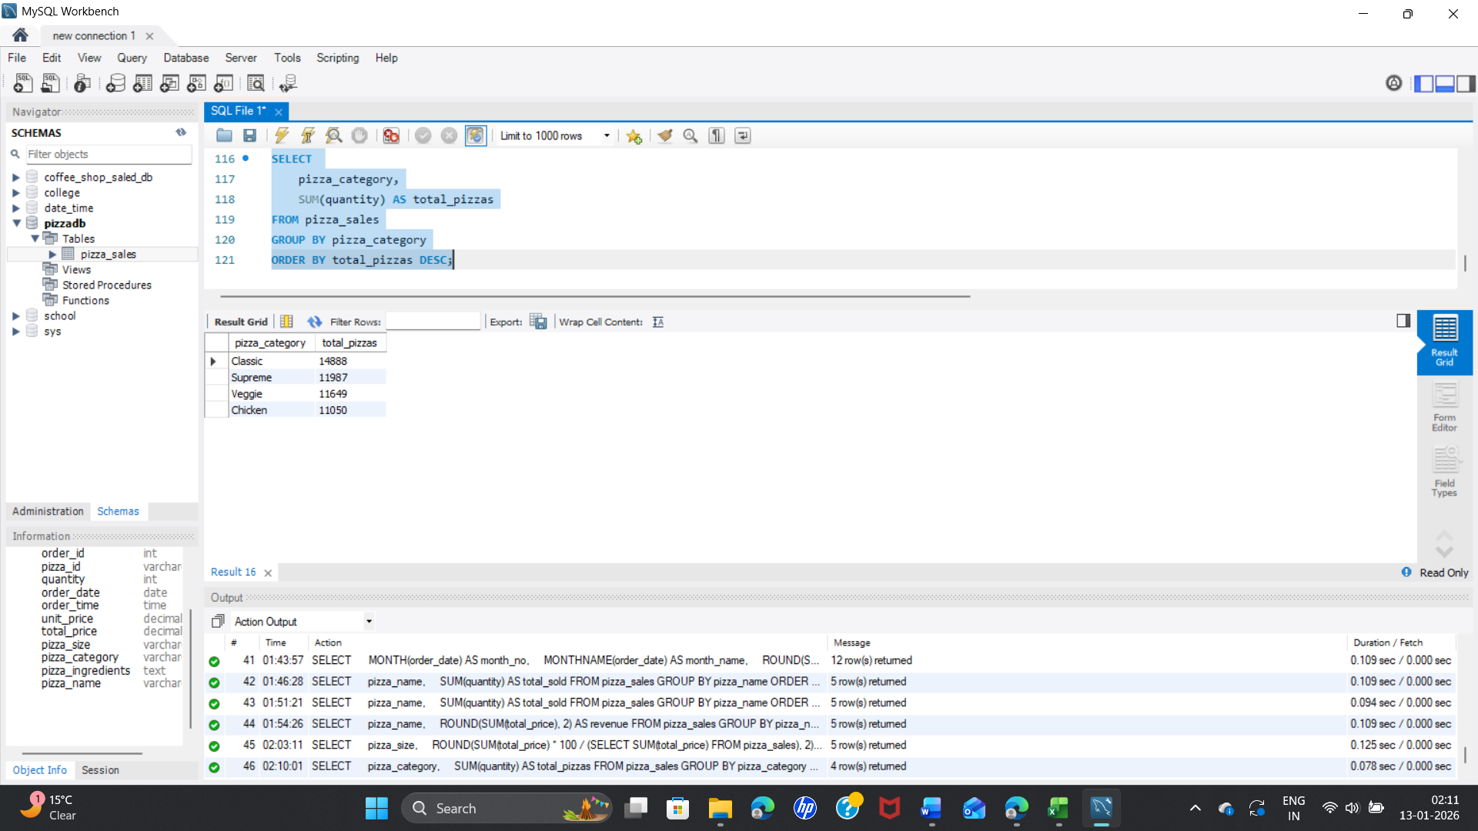

**Pizzas Made per Hour (Kitchen Load)**

SELECT

HOUR(order_time) AS order_hour,

SUM(quantity) AS pizzas_made

FROM pizza_sales

GROUP BY order_hour

ORDER BY pizzas_made DESC;

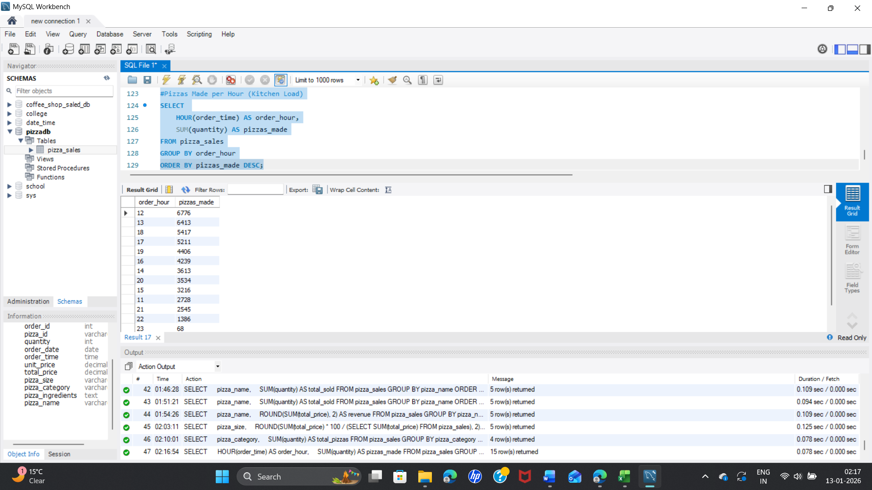

**Estimated Seat Utilization percentage (Assumptions:Seats = 60,Customers per order = 2)**

SELECT

order_hour,

ROUND((orders * 2 / 60) * 100, 2) AS seat_utilization_pct

FROM (

SELECT

HOUR(order_time) AS order_hour,

COUNT(DISTINCT order_id) AS orders

FROM pizza_sales

GROUP BY order_hour

) t

ORDER BY seat_utilization_pct DESC;

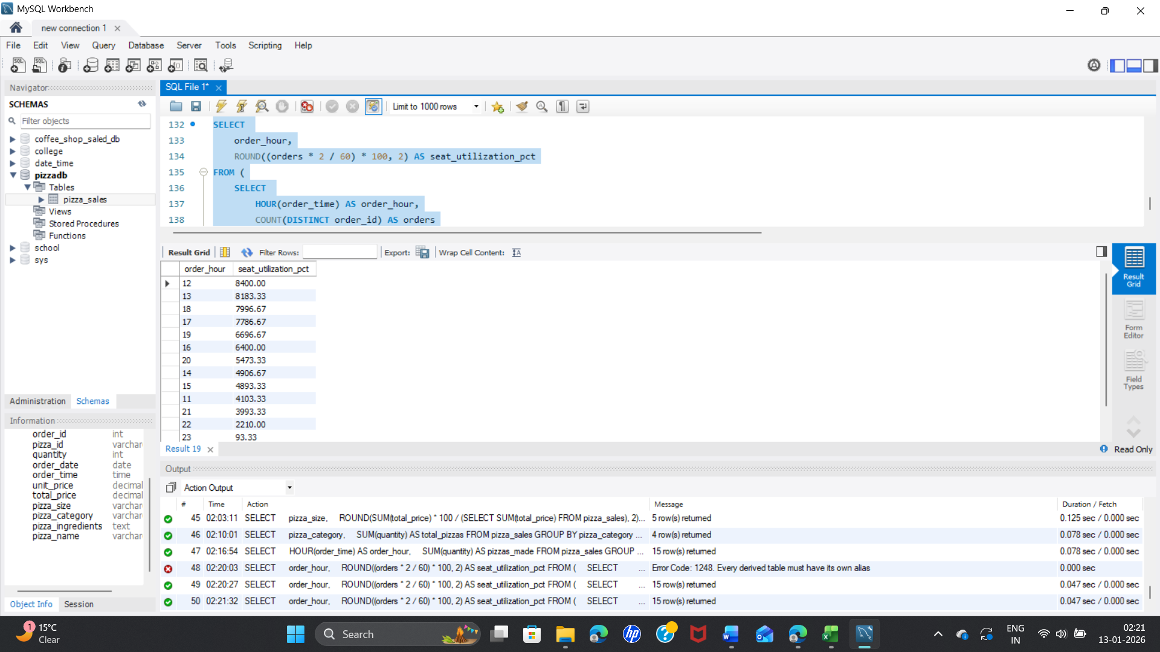

**Maven pizza Challenge**

**1.What days and times do we tend to be busiest?**

**#Busiest Days (by Orders)**

SELECT

DAYNAME(order_date) AS day_name,

COUNT(DISTINCT order_id) AS total_orders,

ROUND(SUM(total_price), 2) AS total_revenue

FROM pizza_sales

GROUP BY day_name

ORDER BY total_orders DESC;

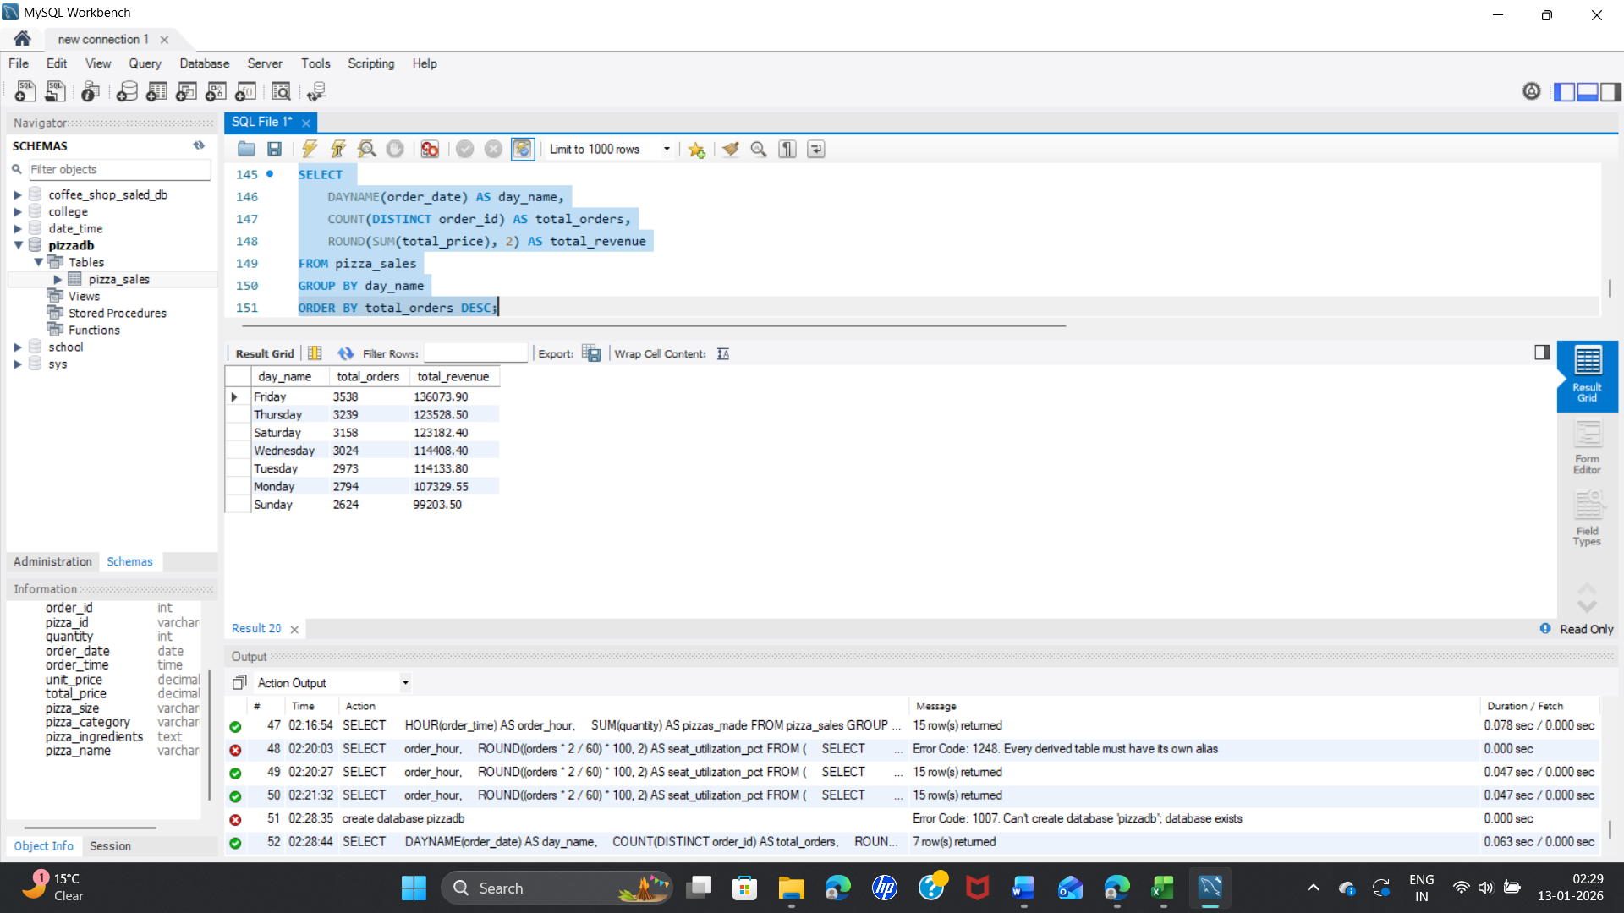

**#Busiest Hours**

SELECT

HOUR(order_time) AS order_hour,

COUNT(DISTINCT order_id) AS total_orders,

ROUND(SUM(total_price), 2) AS total_revenue

FROM pizza_sales

GROUP BY order_hour

ORDER BY total_orders DESC;

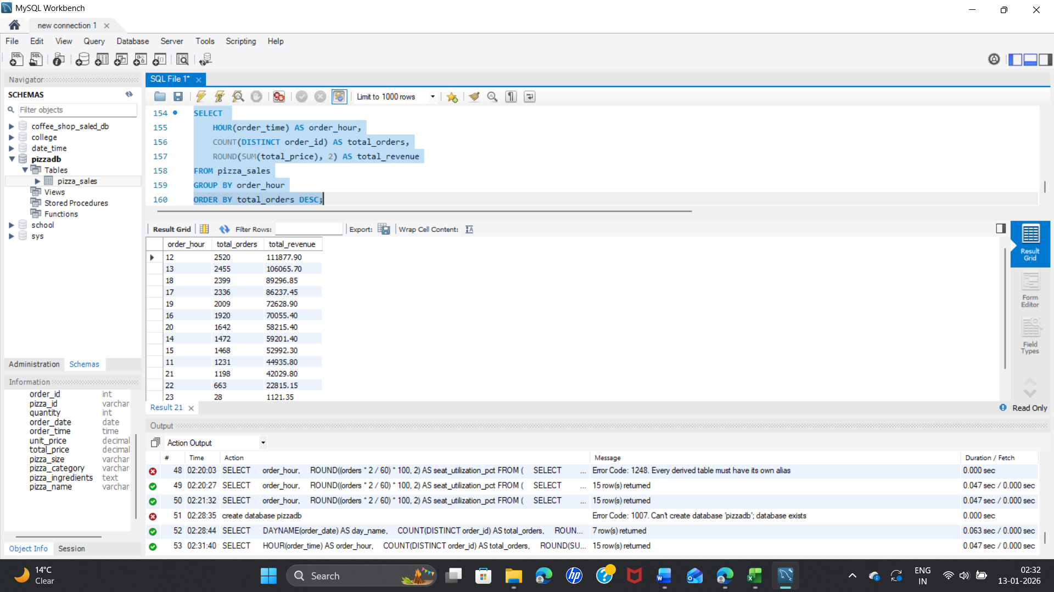

**2. How many pizzas are we making during peak periods?**

**#Pizzas Made per Hour**

SELECT

HOUR(order_time) AS order_hour,

SUM(quantity) AS pizzas_made

FROM pizza_sales

GROUP BY order_hour

ORDER BY pizzas_made DESC;

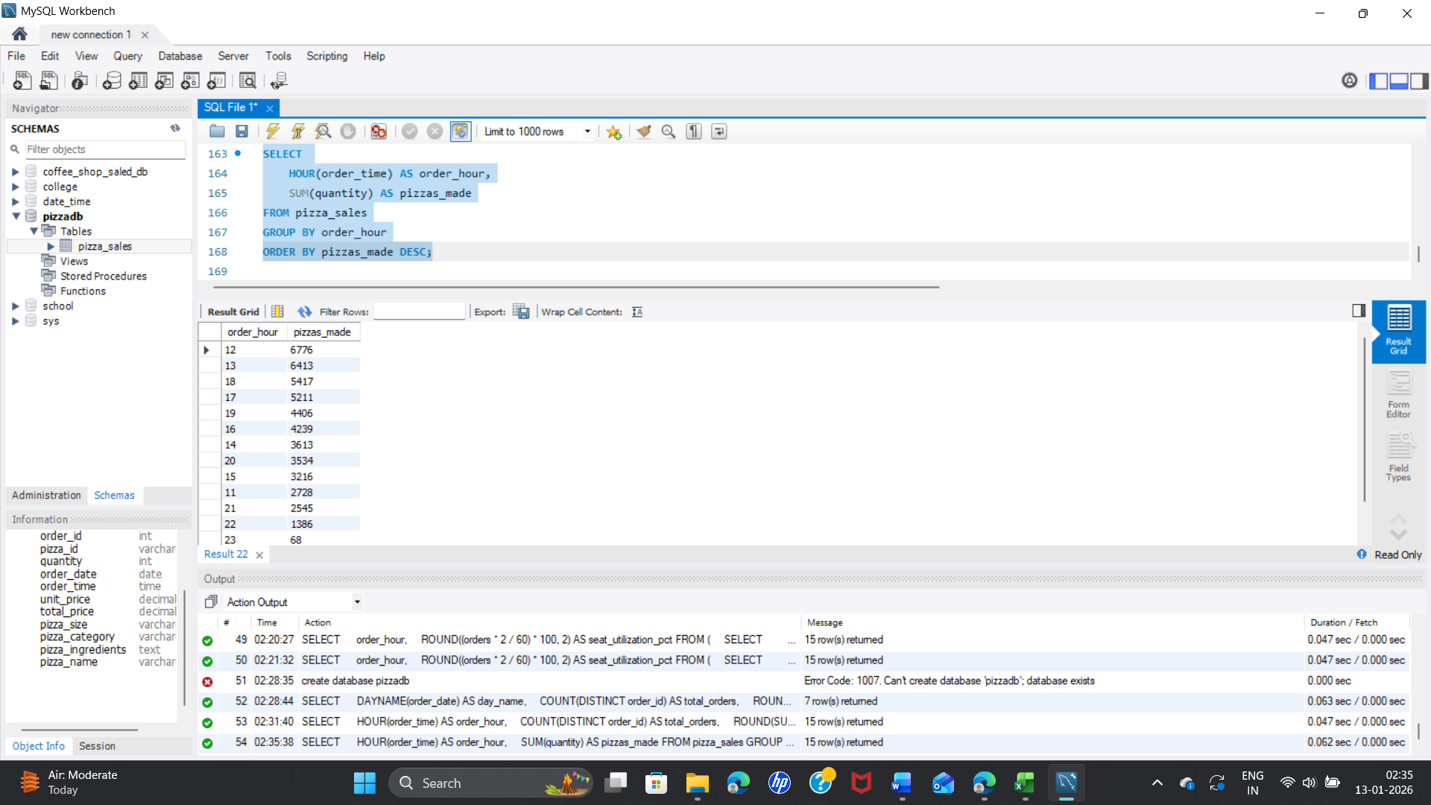

**#Maximum Pizzas in Any Single Hour (Operational Peak)**

SELECT

order_date,

HOUR(order_time) AS order_hour,

SUM(quantity) AS pizzas_made

FROM pizza_sales

GROUP BY order_date, order_hour

ORDER BY pizzas_made DESC

LIMIT 5;

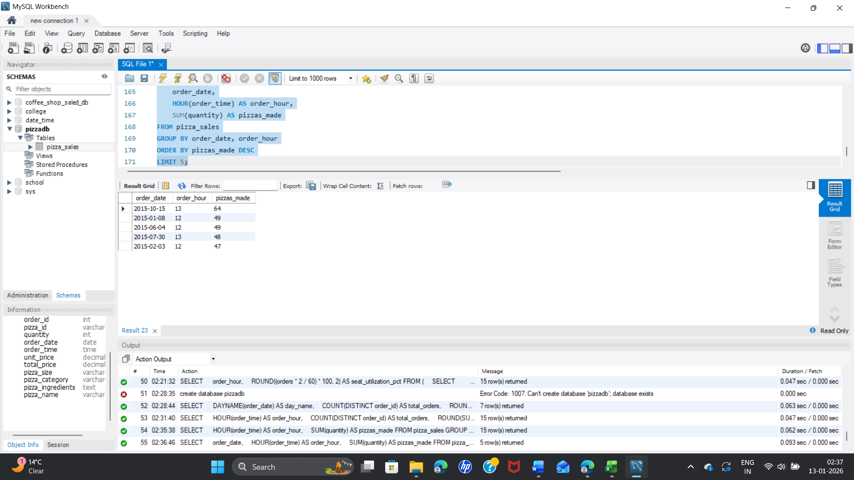

**3. What are our best and worst-selling pizzas?**

**#Best-Selling Pizzas**

SELECT

pizza_name,

SUM(quantity) AS total_sold

FROM pizza_sales

GROUP BY pizza_name

ORDER BY total_sold DESC

LIMIT 5;

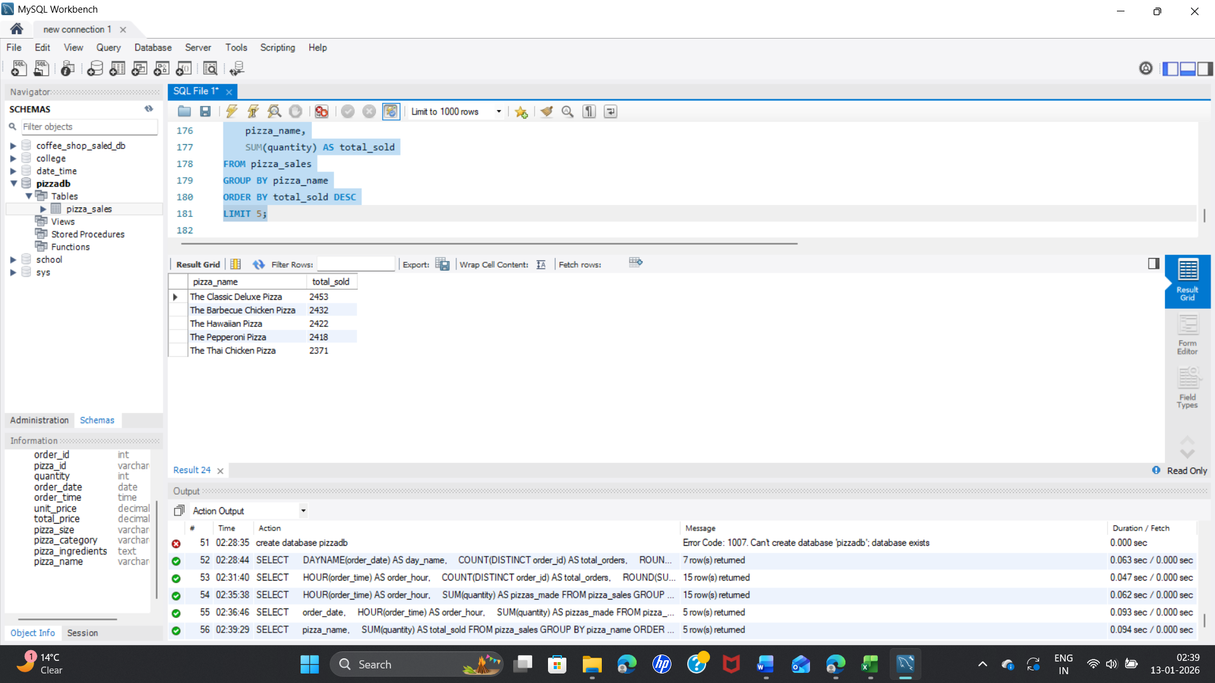

**#Worst-Selling Pizzas**

SELECT

pizza_name,

SUM(quantity) AS total_sold

FROM pizza_sales

GROUP BY pizza_name

ORDER BY total_sold ASC

LIMIT 5;

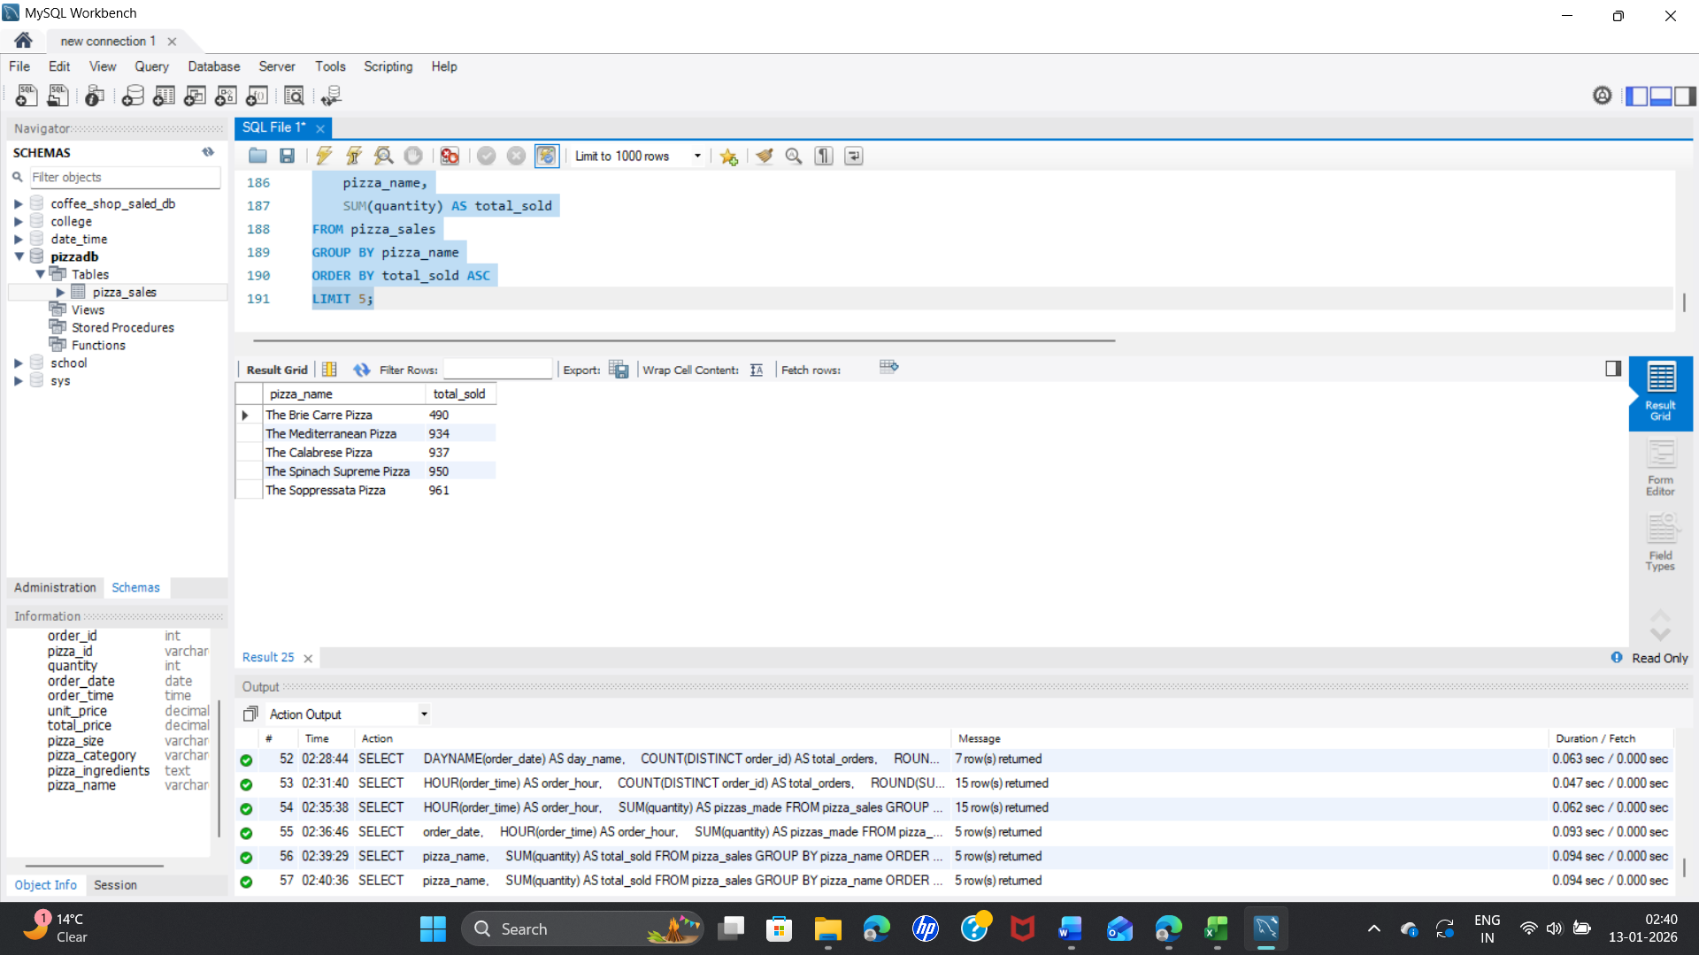

**#Highest Revenue Pizzas**

SELECT

pizza_name,

ROUND(SUM(total_price), 2) AS revenue

FROM pizza_sales

GROUP BY pizza_name

ORDER BY revenue DESC

LIMIT 5;

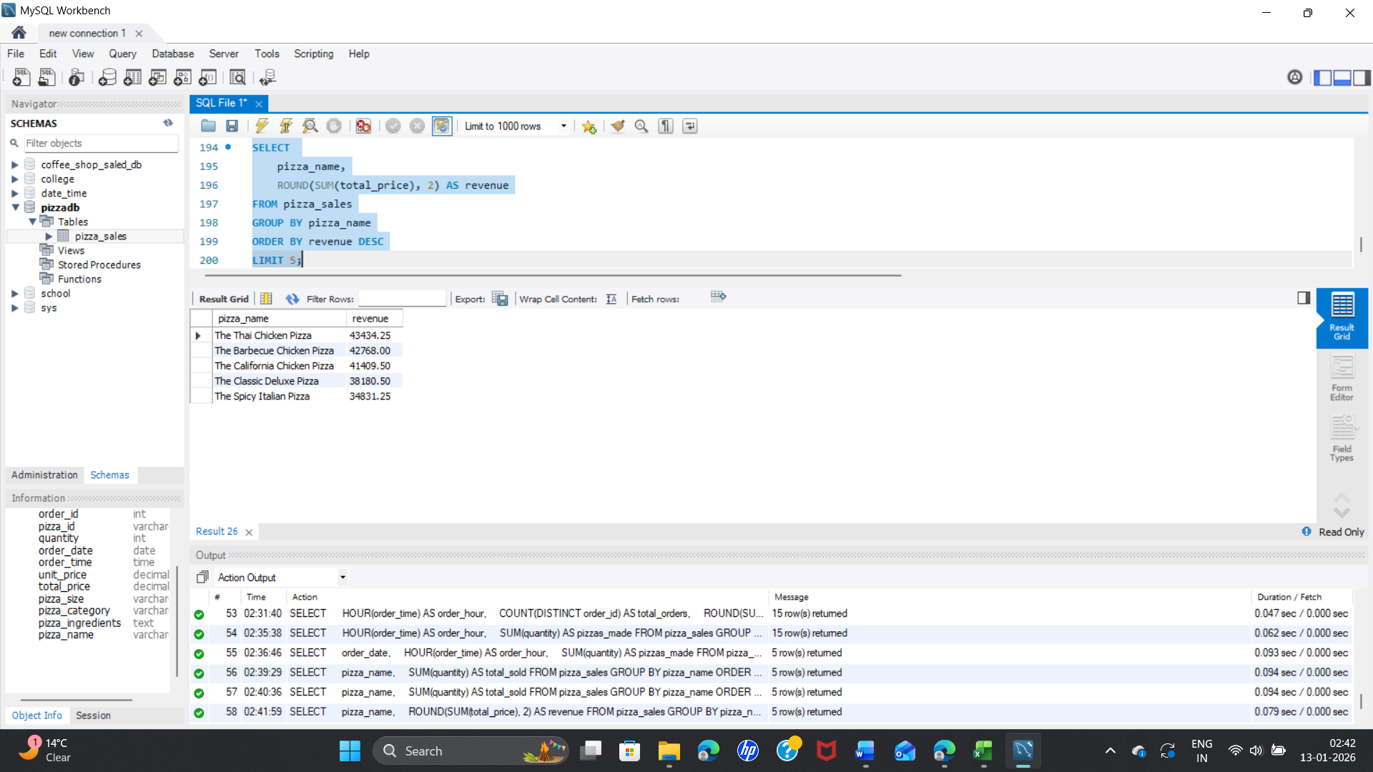

**4. What’s our Average Order Value (AOV)?**

SELECT

ROUND(SUM(total_price) / COUNT(DISTINCT order_id), 2) AS avg_order_value

FROM pizza_sales;

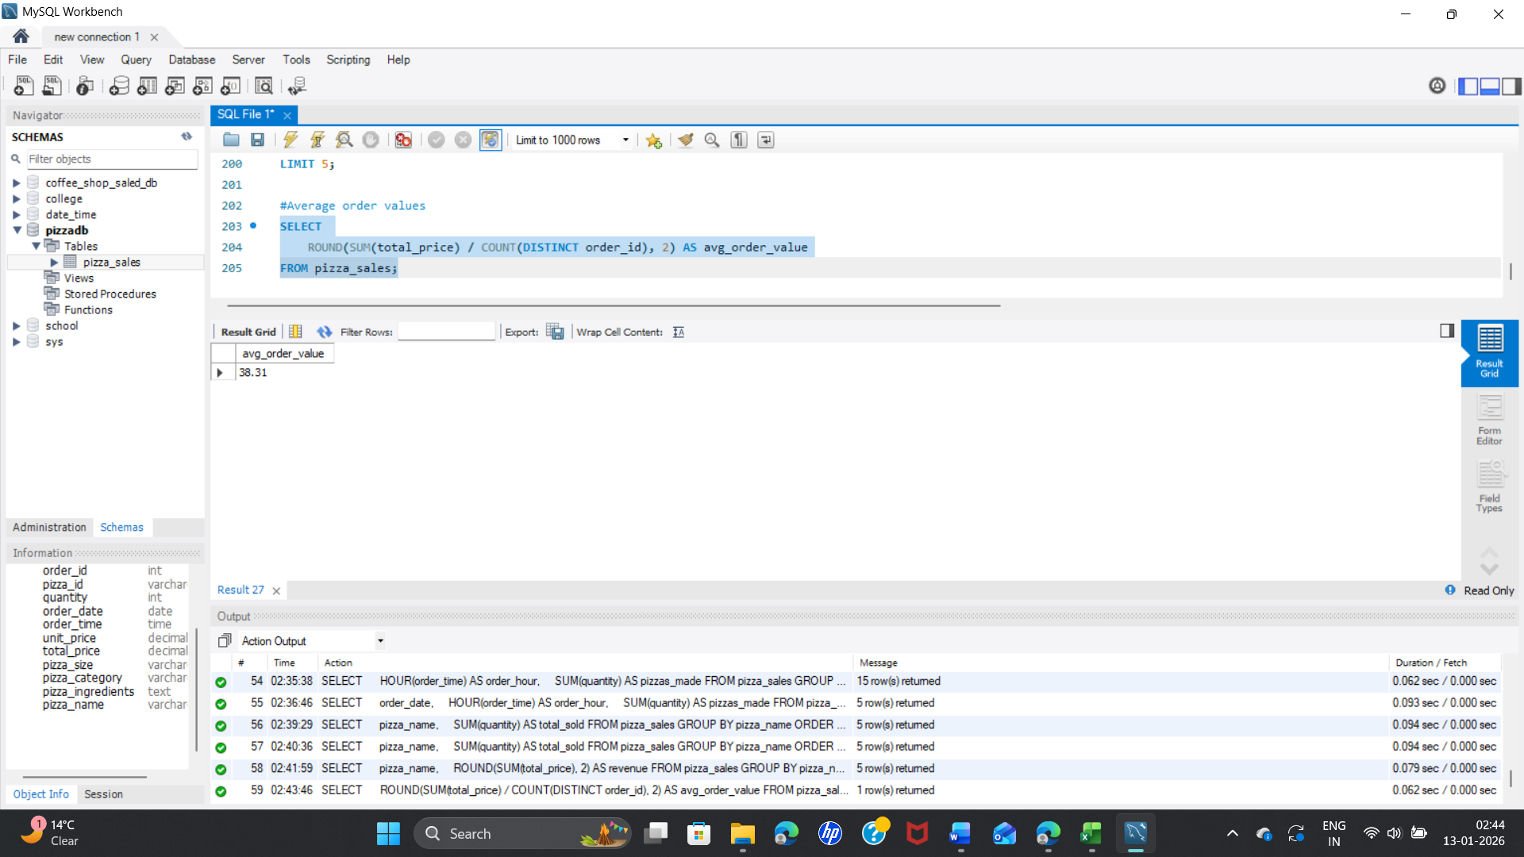

**5. How well are we utilizing our seating capacity?**

Assumptions:

* Total seats = 60
* Avg customers per order = 2

SELECT

order_hour,

ROUND((orders * 2 / 60) * 100, 2) AS seat_utilization_pct

FROM (

SELECT

HOUR(order_time) AS order_hour,

COUNT(DISTINCT order_id) AS orders

FROM pizza_sales

GROUP BY order_hour

) t

ORDER BY seat_utilization_pct DESC;

